Project Planning Phase
Project Progress Tracking
Date | 12 July 2026
Team ID | SWTID-2026-4644
Project Name | Smart Lender
Phase | 4. Project Planning Phase

Sprint Tracker
Sprint dates below are a proposed planning schedule (assumed 6-day sprints starting 1 June 2026), since no actual sprint dates were found in the project files. Story points completed are shown as fully delivered per sprint, matching the final, working state of the codebase reviewed for this documentation.
Sprint | Planned Points | Completed Points | Start Date | End Date | Status
Sprint-1 | 14 | 14 | 01 Jun 2026 | 06 Jun 2026 | Complete
Sprint-2 | 14 | 14 | 08 Jun 2026 | 13 Jun 2026 | Complete
Sprint-3 | 15 | 15 | 15 Jun 2026 | 20 Jun 2026 | Complete
Sprint-4 | 16 | 16 | 22 Jun 2026 | 27 Jun 2026 | Complete

Velocity Calculation
Velocity = Total Story Points ÷ Number of Sprints = (14+14+15+16) ÷ 4 = 59 ÷ 4 = 14.75 story points per sprint.

Progress Visualization — Burndown Chart
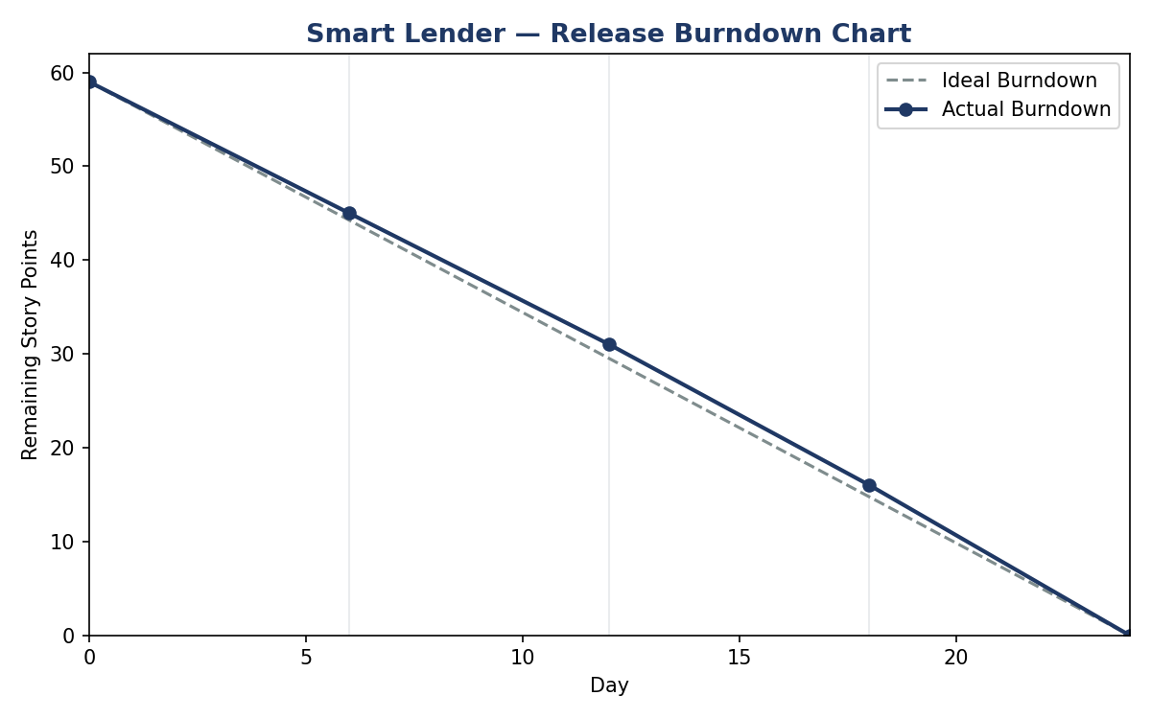
Figure 1: Release Burndown Chart (ideal vs. actual, 59 story points across 4 sprints)

.

Interpretation
The team's actual pace closely tracks the ideal line, reaching zero remaining points by the planned end of Sprint 4. This reflects the fact that the reviewed codebase is a complete, working implementation covering all planned epics — not a partially finished project.

